-------------------------------------------------------------LAB 11.4-------------------------------------------------------------
Task1:
Implementing a Stack (LIFO)
• Task: Use AI to help implement a Stack class in Python with the
following operations: push(), pop(), peek(), and is_empty().
• Instructions:
o Ask AI to generate code skeleton with docstrings.
o Test stack operations using sample data.
o Request AI to suggest optimizations or alternative
implementations (e.g., using collections.deque).
• Expected Output:
o A working Stack class with proper methods, Google-style
docstrings, and inline comments for tricky parts
class Stack:
"""A simple Stack (LIFO) implementation.

Methods:
push(item): Add an item to the top of the stack.
pop(): Remove and return the top item of the stack.
peek(): Return the top item without removing it.
is_empty(): Check if the stack is empty.
"""

def __init__(self):
"""Initialize an empty stack."""
self.items = []

def push(self, item):
"""Add an item to the top of the stack.

Args:
item: The item to be added.
"""
self.items.append(item)

def pop(self):
"""Remove and return the top item of the stack.

Returns:
The item at the top of the stack.

Raises:
IndexError: If the stack is empty.
"""
if self.is_empty():
raise IndexError("pop from empty stack")
return self.items.pop()

def peek(self):
"""Return the top item without removing it.

Returns:
The item at the top of the stack.

Raises:
IndexError: If the stack is empty.
"""
if self.is_empty():
raise IndexError("peek from empty stack")
return self.items[-1]

def is_empty(self):
"""Check if the stack is empty.

Returns:
True if the stack is empty, False otherwise.
"""
return len(self.items) == 0

# Sample test code
if __name__ == "__main__":
stack = Stack()
print("Is empty?", stack.is_empty()) # True
stack.push(10)
stack.push(20)
stack.push(30)
print("Peek:", stack.peek()) # 30
print("Pop:", stack.pop()) # 30
print("Peek after pop:", stack.peek())# 20
print("Is empty?", stack.is_empty()) # False
output:

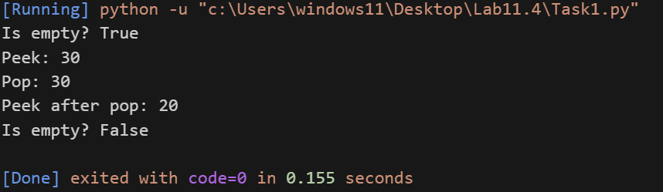
Task2:
Queue Implementation with Performance Review
• Task: Implement a Queue with enqueue(), dequeue(), and is_empty()
methods.
• Instructions:
o First, implement using Python lists.
o Then, ask AI to review performance and suggest a more
efficient implementation (using collections.deque).
from collections import deque

class ListQueue:
"""Queue implementation using Python lists.

Methods:
enqueue(item): Add item to the end of the queue.
dequeue(): Remove and return item from the front.
is_empty(): Check if the queue is empty.
"""

def __init__(self):
"""Initialize an empty queue."""
self.items = []

def enqueue(self, item):
"""Add item to the end of the queue.

Args:
item: Item to add.
"""
self.items.append(item)

def dequeue(self):
"""Remove and return item from the front.

Returns:
The item at the front of the queue.

Raises:
IndexError: If the queue is empty.
"""
if self.is_empty():
raise IndexError("dequeue from empty queue")
# Removing from front of list is O(n)
return self.items.pop(0)

def is_empty(self):
"""Check if the queue is empty.

Returns:
True if empty, False otherwise.
"""
return len(self.items) == 0

class DequeQueue:
"""Queue implementation using collections.deque.

Methods:
enqueue(item): Add item to the end of the queue.
dequeue(): Remove and return item from the front.
is_empty(): Check if the queue is empty.
"""

def __init__(self):
"""Initialize an empty queue."""
self.items = deque()

def enqueue(self, item):
"""Add item to the end of the queue.

Args:
item: Item to add.
"""
self.items.append(item)

def dequeue(self):
"""Remove and return item from the front.

Returns:
The item at the front of the queue.

Raises:
IndexError: If the queue is empty.
"""
if self.is_empty():
raise IndexError("dequeue from empty queue")
# Removing from front of deque is O(1)
return self.items.popleft()

def is_empty(self):
"""Check if the queue is empty.

Returns:
True if empty, False otherwise.
"""
return len(self.items) == 0

# Performance Comparison:
# - ListQueue: enqueue is O(1), dequeue is O(n) due to pop(0) shifting elements.
# - DequeQueue: both enqueue and dequeue are O(1), making it more efficient for large queues.

# Sample test code
if __name__ == "__main__":
print("Testing ListQueue:")
q1 = ListQueue()
q1.enqueue(1)
q1.enqueue(2)
q1.enqueue(3)
print(q1.dequeue()) # 1
print(q1.is_empty()) # False

print("\nTesting DequeQueue:")
q2 = DequeQueue()
q2.enqueue(1)
q2.enqueue(2)
q2.enqueue(3)
print(q2.dequeue()) # 1
print(q2.is_empty()) #
• Expected Output:
o Two versions of a queue: one with lists and one optimized with
deque, plus an AI-generated performance comparison.

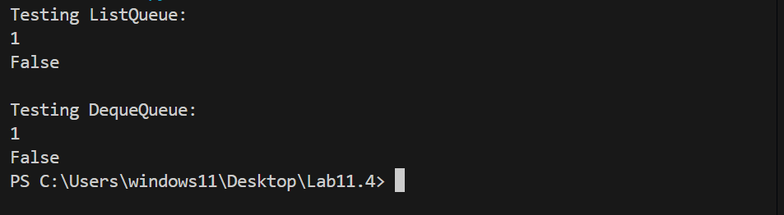
Task 3: Singly Linked List with Traversal
• Task: Implement a Singly Linked List with operations:
insert_at_end(), delete_value(), and traverse().
• Instructions:
o Start with a simple class-based implementation (Node,
LinkedList).
o Use AI to generate inline comments explaining pointer updates
(which are non-trivial).
o Ask AI to suggest test cases to validate all operations
class Node:
"""Represents a node in a singly linked list."""

def __init__(self, data):
"""Initialize node with data and next pointer."""
self.data = data
self.next = None

class LinkedList:
"""Singly linked list implementation."""

def __init__(self):
"""Initialize an empty linked list."""
self.head = None

def insert_at_end(self, data):
"""Insert a new node with the given data at the end of the list.

Args:
data: Data to store in the new node.
"""
new_node = Node(data)
if not self.head:
# If list is empty, new node becomes head
self.head = new_node
return
current = self.head
while current.next:
current = current.next
# Set the next pointer of the last node to new_node
current.next = new_node

def delete_value(self, value):
"""Delete the first node with the specified value.

Args:
value: Value to delete from the list.

Raises:
ValueError: If value is not found.
"""
current = self.head
prev = None
while current:
if current.data == value:
if prev:
# Bypass the current node by updating prev.next
prev.next = current.next
else:
# If head needs to be deleted, move head pointer
self.head = current.next
return
prev = current
current = current.next
raise ValueError(f"{value} not found in list")

def traverse(self):
"""Traverse the list and return elements as a list.

Returns:
List of node data.
"""
elements = []
current = self.head
while current:
elements.append(current.data)
current = current.next
return elements

# Suggested test cases
if __name__ == "__main__":
ll = LinkedList()
# Test insertions
ll.insert_at_end(1)
ll.insert_at_end(2)
ll.insert_at_end(3)
print("After insertions:", ll.traverse()) # [1, 2, 3]

# Test deletion of middle value
ll.delete_value(2)
print("After deleting 2:", ll.traverse()) # [1, 3]

# Test deletion of head
ll.delete_value(1)
print("After deleting 1:", ll.traverse()) # [3]

# Test deletion of last value
ll.delete_value(3)
print("After deleting 3:", ll.traverse()) # []

# Test deletion of non-existent value (should raise ValueError)
try:
ll.delete_value(99)
except ValueError as e:
print("Error:", e) # 99 not found in list False
• Expected Output:
o A functional linked list implementation with clear comments
explaining the logic of insertions and deletions
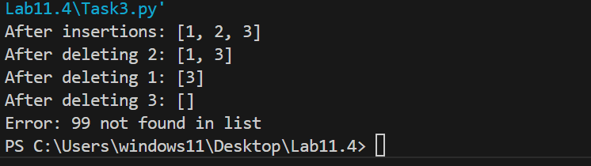
Task 4: Binary Search Tree (BST)
• Task: Implement a Binary Search Tree with methods for insert(),
search(), and inorder_traversal().
• Instructions:
o Provide AI with a partially written Node and BST class.
o Ask AI to complete missing methods and add docstrings.
o Test with a list of integers and compare outputs of search() for
present vs absent elements
class Node:
"""Represents a node in a binary search tree."""

def __init__(self, data):
"""Initialize node with data and left/right pointers."""
self.data = data
self.left = None
self.right = None

class BST:
"""Binary Search Tree implementation."""

def __init__(self):
"""Initialize an empty BST."""
self.root = None

def insert(self, data):
"""Insert a new value into the BST.

Args:
data: Value to insert.
"""
self.root = self._insert_recursive(self.root, data)

def _insert_recursive(self, node, data):
"""Helper method to insert recursively."""
if node is None:
return Node(data)
if data < node.data:
node.left = self._insert_recursive(node.left, data)
elif data > node.data:
node.right = self._insert_recursive(node.right, data)
# If data == node.data, do not insert duplicates
return node

def search(self, value):
"""Search for a value in the BST.

Args:
value: Value to search for.

Returns:
True if found, False otherwise.
"""
return self._search_recursive(self.root, value)

def _search_recursive(self, node, value):
"""Helper method to search recursively."""
if node is None:
return False
if value == node.data:
return True
elif value < node.data:
return self._search_recursive(node.left, value)
else:
return self._search_recursive(node.right, value)

def inorder_traversal(self):
"""Return the inorder traversal of the BST as a list.

Returns:
List of node values in sorted order.
"""
result = []
self._inorder_recursive(self.root, result)
return result

def _inorder_recursive(self, node, result):
"""Helper method for inorder traversal."""
if node:
self._inorder_recursive(node.left, result)
result.append(node.data)
self._inorder_recursive(node.right, result)

# Sample test code
if __name__ == "__main__":
bst = BST()
nums = [7, 3, 9, 1, 5, 8, 10]
for num in nums:
bst.insert(num)

print("Inorder traversal:", bst.inorder_traversal()) # [1, 3, 5, 7, 8, 9, 10]

# Test search for present and absent elements
print("Search 5:", bst.search(5)) # True
print("Search 11:", bst.search(11)) # False
• Expected Output:
o A BST class with clean implementation, meaningful docstrings,
and correct traversal output
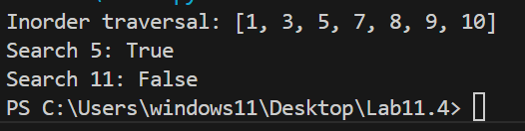
Task 5: Graph Representation and BFS/DFS Traversal
• Task: Implement a Graph using an adjacency list, with traversal
methods BFS() and DFS().
• Instructions:
o Start with an adjacency list dictionary.
o Ask AI to generate BFS and DFS implementations with inline
comments.
o Compare recursive vs iterative DFS if suggested by AI.
from collections import deque

class Graph:
"""Graph implementation using an adjacency list."""

def __init__(self):
"""Initialize an empty adjacency list."""
self.adj_list = {}

def add_edge(self, src, dest):
"""Add an edge from src to dest (undirected).

Args:
src: Source node.
dest: Destination node.
"""
if src not in self.adj_list:
self.adj_list[src] = []
if dest not in self.adj_list:
self.adj_list[dest] = []
self.adj_list[src].append(dest)
self.adj_list[dest].append(src) # Remove for directed graph

def bfs(self, start):
"""Breadth-First Search traversal from start node.

Args:
start: Starting node.

Returns:
List of nodes in BFS order.
"""
visited = set()
queue = deque([start])
result = []

while queue:
node = queue.popleft()
if node not in visited:
result.append(node)
visited.add(node)
# Add all unvisited neighbors to the queue
for neighbor in self.adj_list.get(node, []):
if neighbor not in visited:
queue.append(neighbor)
return result

def dfs_iterative(self, start):
"""Iterative Depth-First Search traversal from start node.

Args:
start: Starting node.

Returns:
List of nodes in DFS order.
"""
visited = set()
stack = [start]
result = []

while stack:
node = stack.pop()
if node not in visited:
result.append(node)
visited.add(node)
# Add neighbors to stack (reverse for consistent order)
for neighbor in reversed(self.adj_list.get(node, [])):
if neighbor not in visited:
stack.append(neighbor)
return result

def dfs_recursive(self, start):
"""Recursive Depth-First Search traversal from start node.

Args:
start: Starting node.

Returns:
List of nodes in DFS order.
"""
result = []
visited = set()

def dfs(node):
if node not in visited:
result.append(node)
visited.add(node)
# Recursively visit all unvisited neighbors
for neighbor in self.adj_list.get(node, []):
dfs(neighbor)

dfs(start)
return result

# Sample test code
if __name__ == "__main__":
g = Graph()
g.add_edge('A', 'B')
g.add_edge('A', 'C')
g.add_edge('B', 'D')
g.add_edge('C', 'E')
g.add_edge('D', 'E')

print("Adjacency List:", g.adj_list)
print("BFS from A:", g.bfs('A')) # ['A', 'B', 'C', 'D', 'E']
print("Iterative DFS from A:", g.dfs_iterative('A')) # ['A', 'C', 'E', 'D', 'B'] or similar
print("Recursive DFS from A:", g.dfs_recursive('A')) # ['A', 'B', 'D', 'E',
• Expected Output:
o A graph implementation with BFS and DFS traversal methods,
with AI-generated comments explaining traversal steps.

